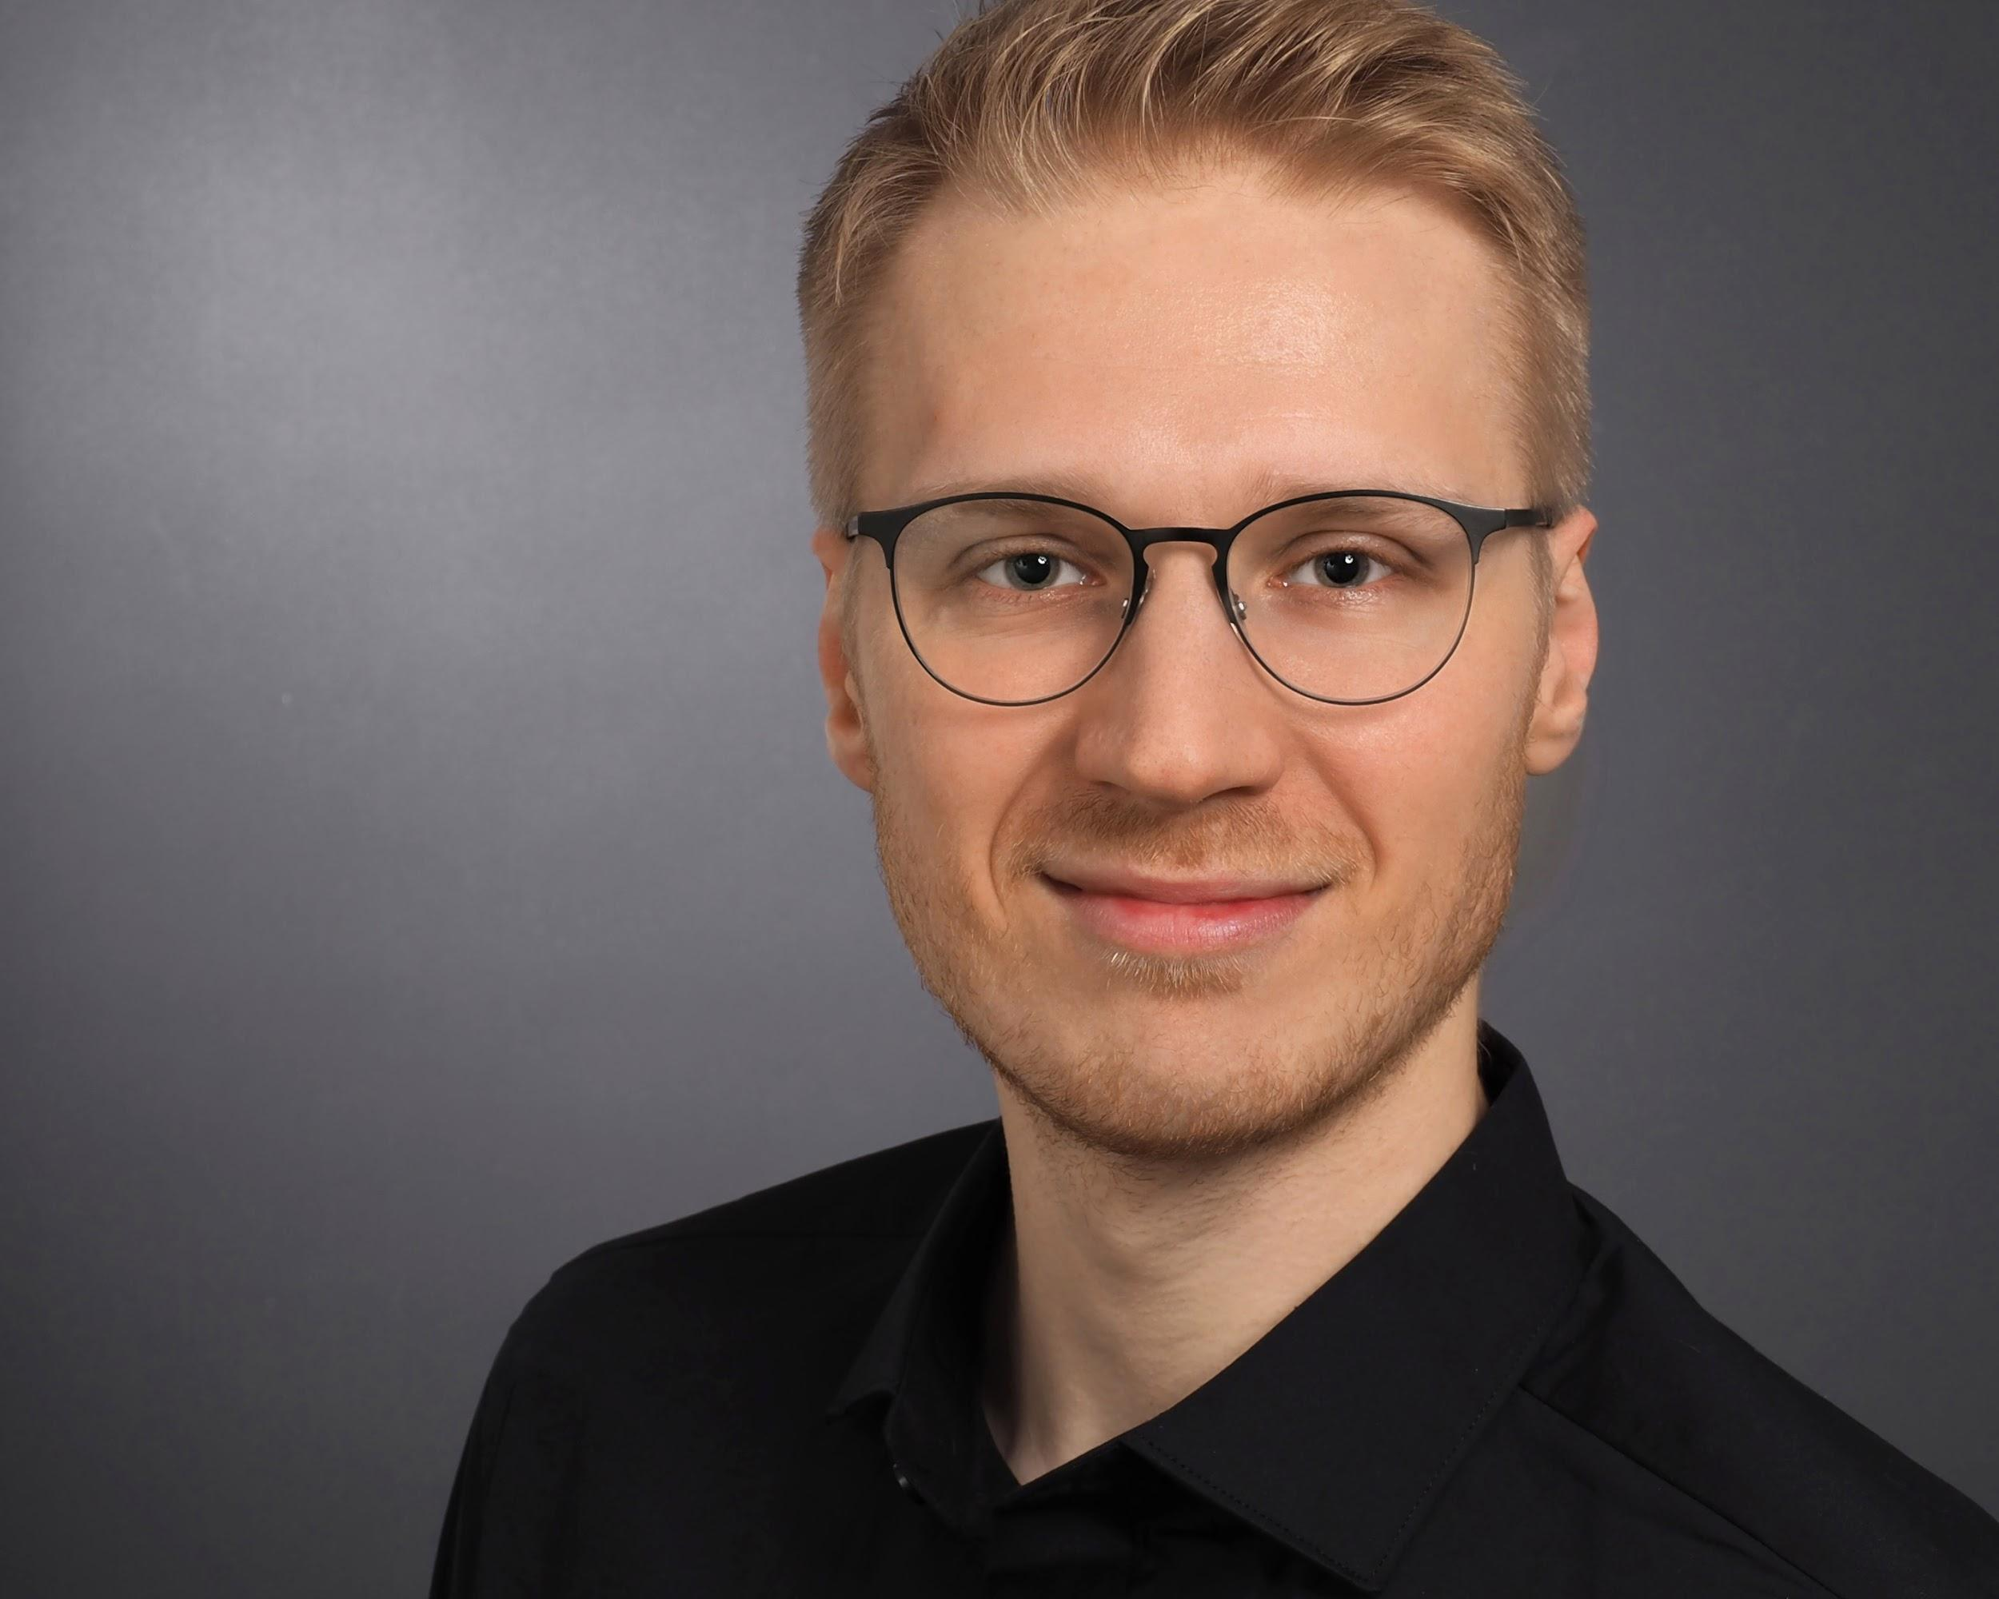
Kai Held
Cloud/DevOps Engineer

📞 +49 151 41650257
📧 held@ka1.io
🌐 https://ka1.io

Skills & Expertise

AWS & Cloud ⬤⬤⬤⬤⬤
- Core-Services: EC2, ECS, EKS, Lambda, API Gateway, DynamoDB, SQS, SNS
- Storage & Databases: S3, EBS, EFS, RDS, Aurora
- Networking: VPC, Route53, CloudFront
- Security: IAM, Cognito, WAF, KMS, Secrets Manager

CI/CD & Automation ⬤⬤⬤⬤⬤
- GitHub, GitLab, Bitbucket

Kubernetes & Containers ⬤⬤⬤⬤⬤
- Deployment: Kubespray, Helm, Kustomize, Crossplane
- GitOps & Dev Tools: ArgoCD, Flux, Skaffold, DevSpace

Observability ⬤⬤⬤⬤⬤
- Monitoring: Prometheus, Grafana, AWS CloudWatch
- Logging: Loki, Kibana (ELK), ElasticSearch, OpenSearch
- Tracing: Tempo

Authorization & Authentication ⬤⬤⬤⬤◯
- OAuth2 (& PKCE), OIDC
- SAML
- Tools: AWS Cognito, Keycloak

Development ⬤⬤⬤⬤◯
- Full-Stack: Astro, Remix, Nuxt
- Backend: Go, Python, JavaScript, TypeScript
- Frontend: React, Vue.js

AI & LLMs ⬤⬤⬤⬤◯
- API SDKs: OpenAI, Anthropic Claude, Google Gemini, Mistral
- Vector Databases: Chroma, Weaviate, Qdrant, pgvector
- Tools: Haystack, LangChain, Langfuse, Flowise, Streamlit, Chainlit
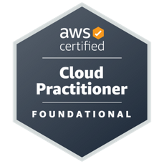
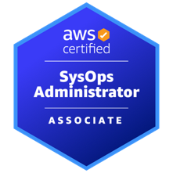
Certificates & Trainings
- AWS Certified SysOps Administrator – Associate
- AWS Certified Cloud Practitioner
https://www.credly.com/users/kai-poblocki/badges

Projects/Contracts

BMW AG
April 2024 – Present
Senior AWS DevOps Engineer
ℹ️ Central Cloud Platform team, focusing on enabling internal customers (e.g. https://bmw.de) through robust cloud solutions (AWS).
- AWS CDK (TypeScript):
- CI/CD: GitHub Actions
- Observability: Grafana, Loki, OpenSearch
- Fullstack Development: Vue.js & Nuxt 3

Rohde & Schwarz SIT
October 2023 – March 2024
Backend Python Engineer
ℹ️ Conceptualizing & development of need-to-know domain-based identity and access management in a highly secure Environment.
- Backend development (Python): API & microservice development

Bundesdruckerei GmbH
January 2023 – April 2024
Site Reliability Engineer
ℹ️ Constructing & operating a data science platform in a highly secure environment.
- High Security Kubernetes Bootstrapping: Kubespray
- GitOps: FluxCD
- Monitoring/Logging: Prometheus, Grafana, Loki, Elasticsearch
- Storage: MinIO, Longhorn
- Authentication: Keycloak
- Infrastructure as Code (IaC): Ansible, Helm, Kustomize
- CI/CD with GitLab

InformMe
April 2023 – October 2023
Senior AWS DevOps Engineer
ℹ️ Architecting & Developing GDPR compliant AWS Account Factory for MedTech Startup.
- Architecture: AWS Control Tower Setup, Service Catalog, CfCT Pipeline, Node.js-Lambdas
- Infrastructure as Code: AWS CDK (TypeScript), CloudFormation
- AWS Identity Center (SSO)
- Custom SCPs, Config Rules & SRA
- On-Prem Migration to ECS Fargate & Lambda

Volkswagen AG (via Rackspace)
Dezember 2022 – January 2023
Senior Cloud Architect (AWS)
ℹ️ Supporting Volkswagen short-term around AWS IAM & resolving several findings of an internal revision; analyzing the existing Environment and define security solutions with minimal effort.

Eurofins
July 2021 – November 2022
DevOps Engineer (AWS, Kubernetes)
ℹ️ Architecting & Engineering AWS EKS (Kubernetes) & supporting AWS Services in a Greenfield Project.
- Greenfield: Setting up & Maintaining EKS (Terraform, Crossplane)
- Kubernetes: Helm, ArgoCD, AWS LB Controller, ExternalDNS, External Secrets, Consul, EFS CSI
- Kubernetes monitoring & Logging: Prometheus, Grafana, Loki, Elastic Search
- Kubernetes security: Cluster Hardening (Bottle Rocket)
- Setting up Kubernetes Authentication via OAuth2/OIDC (PingID) & AWS Cognito
- Migrating on-prem workloads to AWS Serverless Stack: Lambda, API Gateway, Cognito, DynamoDB
- Setting up AWS Security: IAM, SSM, CloudTrail, Secret Manager
- Setting up & Maintaining Kubernetes-native development (Skaffold)
- Infrastructure as Code (Terraform, Crossplane)
- CI/CD Pipelines with Azure DevOps & GitLab
- Linux Administration (Debian, Ubuntu, RHEL)
- Programming with Bash, Python & Go
- Data Engineering (AWS RDS: PostgreSQL, MS SQL)

Siemens AG & Siemens Energy
October 2020 – June 2021
AWS Cloud/DevOps Engineer
ℹ️ Migration of on-premise B2B E-Learning Platform to AWS ECS Cluster & general AWS Support for Siemens Energy Carve-Out.
- Infrastructure as Code (Terraform, Ansible)
- Setting up AWS Security: IAM, SSM, CloudTrail, Secret Manager
- Setting up SAML & OIDC Authentication
- Working with Container-Tools: Docker, ECS
- CI/CD Pipelines with GitLab
- Linux administration (Debian, Ubuntu)
- Scripting with Bash, Python, JavaScript & Go
- Data Engineering (AWS RDS: PostgreSQL, MS SQL)
- Configuration and deployments of EC2 autoscaling Groups and Launch Templates with load balancing

Professional Experience

ventx Gmbh
June 2020 – December 2022
AWS Cloud/DevOps Engineer
- Working on several DevOps Projects
- Architecting AWS Cloud Frameworks
- CI/CD with BitBucket, Gitlab, Jenkins and Jira
- Linux administration (Debian, Ubuntu, CentOS)
- Working with Container-Tools: Kubernetes, OpenShift, Docker
- Consulting and Support for the DevOps Teams
- Documentation of development
- Building highly available and scalable Multi-Tier AWS infrastructure
- Building serverless infrastructure with AWS Lambda, API Gateway and DynamoDB
- Infrastructure as Code with Terraform and CloudFormation
- Configuration and deployments of EC2 autoscaling Groups and Launch Templates with load balancing

Bamberger VerlagsGruppe
February 2019 – May 2020
System Engineer
- Agile project coordination (e.g. Development of MS Dynamics NAV, Helpdesk-, Wiki-Software)
- Educational data mining/scraping with Python for Learning Analytics and Business Intelligence
- Data engineering (Python: Numpy, Pandas) and maintenance of databases (MySQL, PostgreSQL)
- Web development (HTML, CSS, JavaScript) and deployment (Linux: Debian, Ubuntu, CentOS)
- Defined system standards and processes for provisioning and maintaining software on Linux
- Developed scripts for unattended installations (start scripts, installation automation, etc.)
- Maintaining on-premise server infrastructure (Windows; Linux: Debian, Ubuntu, CentOS; VMWare)
- Project budget planning (e.g. ~105k € image database project, ~95k € ERP development)

C.C.Buchner Verlag
May 2015 – February 2019
DevOps Engineer (working student)
- Creating workflows to optimize processes
- Automating tasks with Python (e.g. conversion scripts for various media outputs)
- Sub-project management and assistance
- Front- and Backend web development (e.g. shop website, ticketing system)
- Maintaining on-premise server infrastructure
(WIndows, Linux)

Computing Centre University of Bamberg
January 2013– May 2015
System Administrator & IT-Supporter (student assistant)
- Maintenance of university data centre hard- and software
- Creating install-images for PC-Pools and maintaining hardware
- Network administration (Linux: Debian, Windows Server)

Education

April 2017 – March 2020
University of Erlangen-Nuremberg:
Analytical Philosophy (Master of Arts, grade: 1.2)

October 2012 – March 2017
University of Bamberg:
Philosophy and Political Science (Bachelor of Arts, grade: 1.5)

Scholarships
March 2016 – March 2020
Scholarship of the Max Weber Program according to the Bavarian Eliteförderungsgesetz

November 2017 – March 2020
Online-Scholarship e-fellows.net

Languages
- German: native
- English: fluent (spoken and written)
- Polish: intermediate
- French: basic

